
VISUAL PROGRAMMING FOR DATA SCIENCE
PRACTICAL 1

Date Given : 10th MARCH 2026 (TUESDAY)
Submission Date : 17th MARCH 2026 (TUESDAY)
Date Submitted : 17th MARCH 2026 (TUESDAY)
Weightage : 20%
Semester : FEBRUARY 2026
Lecturer : AHMAD LUQMAN BIN AHMAD KAMAL ARIFFIN

Instruction to students:
- This is a Group Assignment.
- Complete this cover sheet and attach it to your Assignment (first page).

Student declaration:
We declare that:
- This assignment is our own work
- We understand what is meant by plagiarism
- Our lecturer has the right to deduct our marks in the case of:
- Late submission
Any plagiarism found in our assignment.
MUHAMMAD HARISH HAQIM BIN ADNAN | AFNAN FARISH BIN ABDUL RAHIM | KUVALESAN A/L RAVICHANDRAN | SURIANA BINTI ABDULLAH
012025020434 | 012025021256 | 012025021382 | 012025021261
 | 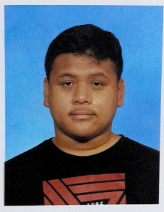 |  | 

MARKS: | Total
 |  | 100

ACKNOWLEDGEMENT
We the members of Group A, would like to express our heartfelt gratitude to our lecturer, Sir Ahmad Luqman Bin Ahmad Kamal Ariffin, for his invaluable guidance and encouragement throughout the course. The lecturer’s explanation and support during the lectures have significantly improved the group’s comprehension of the various data cleaning and transformation techniques. The lecturer’s feedback has also been instrumental in shaping the quality of the work produced by the group members.
We also wish to express our gratitude to the entire group members, Afnan, Haqim, Kuva, and Suriana, for their collaboration and efforts in the production of the assignment. The entire group members were instrumental in the production of the assignment. The spirit of cooperation and the entire group members’ efforts ensured that the group was able to successfully complete the practical.
We would also wish to express our gratitude to our peers and families for their encouragement during the production of the report. The encouragement from the peers and families motivated the entire group members to successfully complete the assignment.
Table of Contents
1.0 INTRODUCTION 1
1.1 Purpose and Objectives 1
1.2 Scope of Work 1
1.3 Significance 1
2.0 QUESTION 1: DATA IMPORT AND BASIC INSPECTION 2
2.1 Import Pandas Library 2
2.2 Load The Raw Dataset 3
2.3 Data Types 3
2.4 The Original Shape of the Dataset 4
2.5 The Head Function 4
2.6 The Dataset Information 5
2.7 Total Null Values from Each Column 5
3.0 QUESTION 2: HANDLING DUPLICATES AND MISSING VALUES 6
3.1 Count Duplicates 6
3.2 Display Duplicate Rows 7
3.3 Dropping Duplicate Rows 8
3.4 Calculating the Age Mean 9
3.5 Fill Missing Age with Mean Value 9
3.6 Finding The Product Mode 10
3.7 Fill Missing Product Category Data with Mode Value 10
3.8 Dropping Rows with Missing Customer Name 11
4.0 QUESTION 3: HANDLING OUTLIERS 11
4.1 Q1 and Q3 Calculation 12
4.2 IQR Calculation 12
4.3 Calculations of Lower and Upper Bound 12
4.4 Filtering the Outliers 13
4.5 New Shape of The Dataset 14
5.0 QUESTION 4: DATA TRANSFORMATION AND EXPORT 15
5.1 New Column: Spend Category 15
5.2 Standardized Product_Category Column 17
5.3 Save Fully Cleaned and Transformed Dataset 18
6.0 QUESTION 5: PRESENTATION 19
7.0 CONCLUSION 20
REFERENCES 21

LIST OF FIGURES
Figure 2.1: Program code for importing Panda’s library 2
Figure 2.2: Program code and output for load raw dataset 3
Figure 2.3: Program code and output for the datatypes 3
Figure 2.4: Program code and output for original shape of the dataset 4
Figure 2.5: Program code and output for head function 4
Figure 2.6: Program code and output for the dataset’s information 5
Figure 2.7: Program code and output for total null values 5
Figure 3.1: Program code and output for counting duplicates 6
Figure 3.2: Program code and output for displaying duplicate rows 7
Figure 3.3: Program code and output for displaying the exact duplicated rows 7
Figure 3.4: Program code and output for dropping duplicate rows 8
Figure 3.5: Program code and output for age mean 9
Figure 3.6: Program code and output for filling missing age 9
Figure 3.7: Program code and output for finding the product mode 10
Figure 3.8: Program code and output for filling missing product category 10
Figure 3.9: Program code and output for dropping rows with missing customer name 11
Figure 4.1: Program code and output for calculating Q1 and Q3 12
Figure 4.2: Program code and output for calculating IQR 12
Figure 4.3: Program code and output for calculating the bounds 12
Figure 4.4: Program code and output for filtering the outliers 13
Figure 4.5: Program code and output for printing the new shape 14
Figure 5.1: Program code and output for new column and categorise the data 15
Figure 5.2: Program code and output for standardized product category 17
Figure 5.3: Program code and output for saving the new dataset 18

EXTERNAL LINK FOR PROGRAM CODE
Google Drive Link: https://drive.google.com/drive/folders/1B_cn9YNqoTEEo-gHZ8H_yiTJ5oCT1hCC?usp=sharing

INTRODUCTION
In the modern era of big data, the ability to transform raw, unstructured information into actionable business intelligence is a critical skill for any data professional. This assignment, Practical 1: Data Cleaning and Transformation, serves as a foundational exercise in the course CCS23503 Visual Programming for Data Science. Operating in the role of a Junior Data Analyst, students are tasked with managing a realistic data pipeline using industry-standard tools, specifically Python within a Jupyter Notebook for this assignment.

Purpose and Objectives
The primary objective of this assignment is to fulfill Course Learning Outcome 2 (CLO2), which requires students to perform data cleaning, transformation, and integration techniques using visual programming tools (GeeksForGeeks, 2026). Data in its raw form is rarely ready for immediate analysis where it is often plagued by "dirty" data issues such as missing values, duplicate records, and extreme outliers that can distort business reports and lead to inaccurate conclusions. By engaging with the provided P1_data.xlsx dataset, students will learn to identify these quality issues and apply programmatic solutions to resolve them.

Scope of Work
This practical application is divided into several critical phases of the data science lifecycle:
- Data Inspection: Using the panda’s library to load data and identify the exact count of missing values and data types (GeeksForGeeks, 2026).
- Data Cleaning: Implementing advanced techniques such as mean imputation for numerical gaps (Age), mode imputation for categorical blanks (Product_Category), and the removal of duplicate records (GeeksForGeeks, 2026).
- Statistical Filtering: Utilizing the Interquartile Range (IQR) method to detect and remove extreme anomalies in spending data, ensuring the integrity of the final analysis (GeeksForGeeks, 2026).
- Feature Engineering: Transforming the cleaned data by creating new categorical features, such as a Spend_Category (Low, Medium, High), and standardizing text formats to uppercase for consistency (GeeksForGeeks, 2026).

Significance
By completing this assignment, we will demonstrate our proficiency in maintaining a logical and chronological data workflow from raw import to the export of a refined final_P1_data.csv file. Furthermore, the requirement of a written report and a formal 5-minute presentation ensures that students can communicate their technical findings effectively to stakeholders, bridging the gap between raw code and business value.

QUESTION 1: DATA IMPORT AND BASIC INSPECTION
According to (Coursera Staff, 2025), Pandas is an open-source library in Python for data analysis and manipulation. It allows you to efficiently work with structured data through flexible data structures and various data-handling capabilities. To build your understanding of pandas and how you could use it for your professional tasks, explore the core components of this library, common applications, and advantages and limitations to consider.

Import Pandas Library
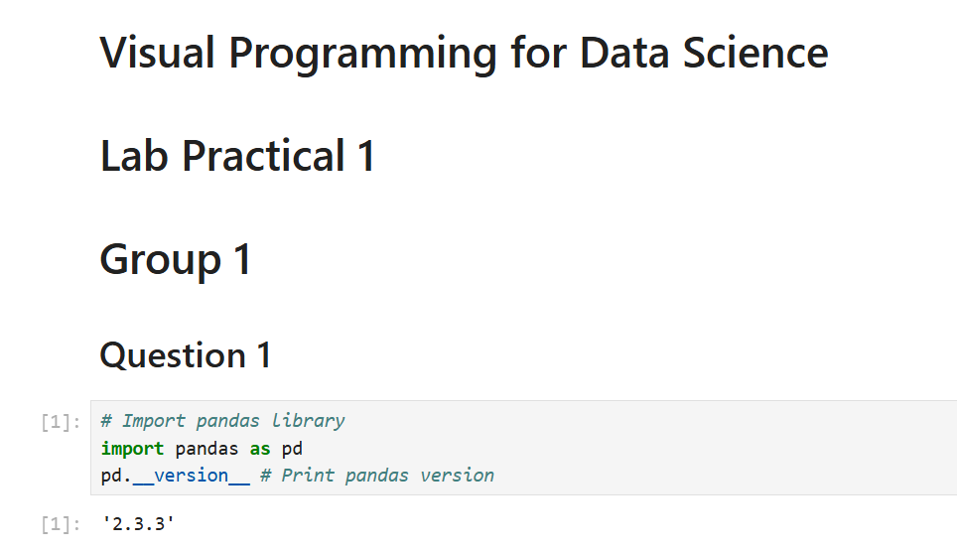
Figure 2.1: Program code for importing Panda’s library
Figure 2.1 shows the program code for importing Panda’s library and output the current version of the Pandas library. The as pd is to create the alias name for our pandas library. pd.__version__ is used to display the current version of our pandas library installed inside the system.

Load The Raw Dataset
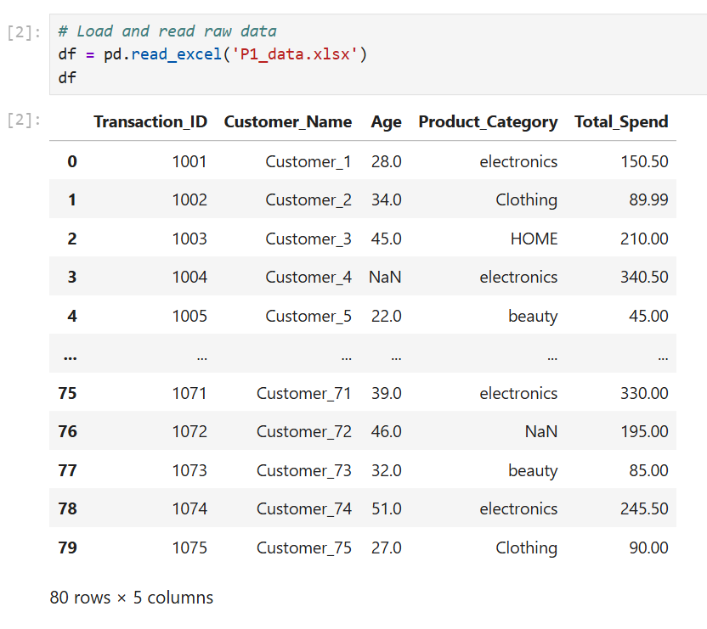
Figure 2.2: Program code and output for load raw dataset
Figure 2.2 shows the program code for the load raw dataset alongside with the output. The df variable is initialised and assigned to the excel file name P1_data.xlsx by using the function read_excel. As we can see, the dataset is not formatted and there is no separated column, and the data types are all text even though there are numerical values.

Data Types
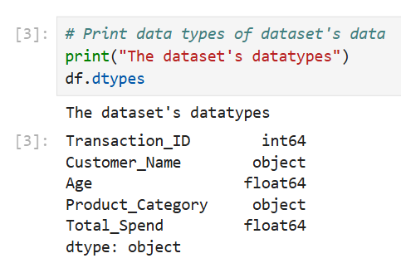
Figure 2.3: Program code and output for the datatypes
Figure 2.3 shows the program code for the dataset’s datatypes along with its output. The function .dtypes is used to display all data types from each column of the dataset. There are over three different data types from the dataset which are int64, object, and float64.

The Original Shape of the Dataset
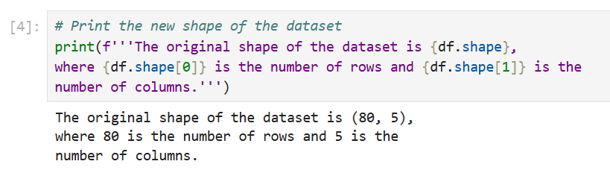
Figure 2.4: Program code and output for original shape of the dataset
Figure 2.4 shows the program code and output for original shape of the dataset where 80 is the number of rows and 5 is the number of columns.

The Head Function
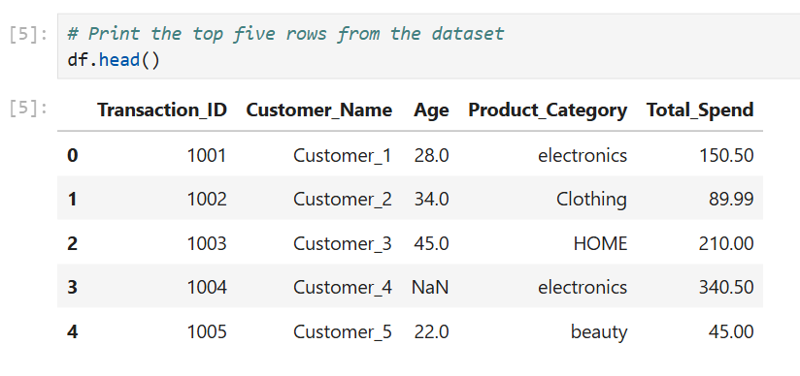
Figure 2.5: Program code and output for head function
Figure 2.5 shows the program code and output for the head function of the data frame. The .head() function is used to display the top 5 rows of the dataset. It displays the top five rows from the dataset.

The Dataset Information
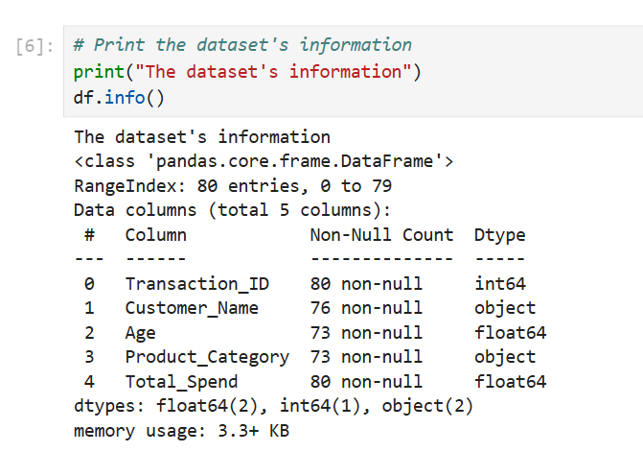
Figure 2.6: Program code and output for the dataset’s information
Figure 2.6 shows the program code for the dataset information. The .info() function outputs the dataset information consist of the column names, the index, the non-null count and the datatype of each column from the dataset. Information that was included such as the type class of the df variable, the total columns, the column name, total non-null count and also the data types of each columns.

Total Null Values from Each Column
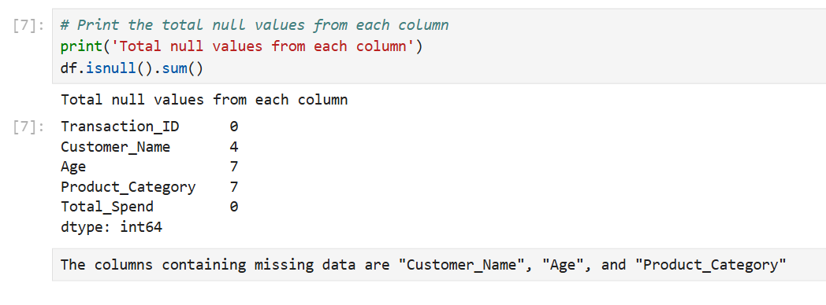
Figure 2.7: Program code and output for total null values
Figure 2.7 shows the program code for the total null values from each column. It shows how many null values were found in each column by using .isnull().sum(). There are only three column that contain null values. The explanation about the columns containing missing data shown in the text cell below from the output Figure 2.6. The Transcation_ID column contains 0 null values, the Customer_Name column contains 4 null values, the Age column contains 7 null values, the Product_Category column contains 7 null values and finally the Total_Spend contains 0 null values.

QUESTION 2: HANDLING DUPLICATES AND MISSING VALUES
In this section, we will discuss and code Python on how to handle the duplicates and missing values from the dataset. We will count how many duplicates, identify the duplicates rows, delete the duplicates rows and filling missing age values with mean value, filling missing product category values with the mode of the product category and finally delete rows that contains missing customer names.

Count Duplicates
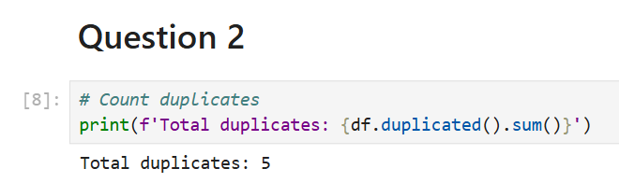
Figure 3.1: Program code and output for counting duplicates
Figure 3.1 shows the program code for counting duplicates alongside with the output. It is stated that the total duplicates are five. The .duplicated() function is used to capture the duplicated rows and .sum() function is used to count the overall duplicated rows.

Display Duplicate Rows
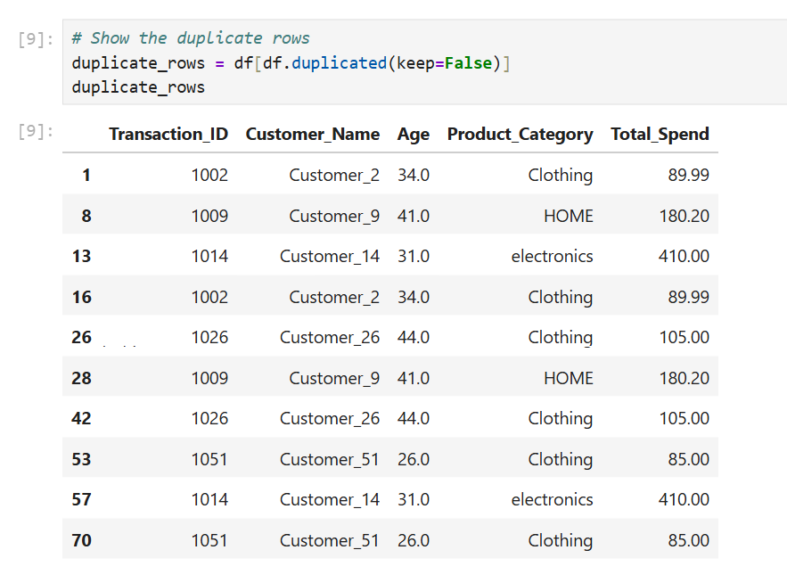
Figure 3.2: Program code and output for displaying duplicate rows
Figure 3.2 shows the program code for displaying duplicate rows alongside with the output. It is stated that there are over 10 rows that have the same rows information. If we want to display the exact 5 rows that are duplicated we can change the “keep” parameter value into ‘first’ just like in Figure 3.3.
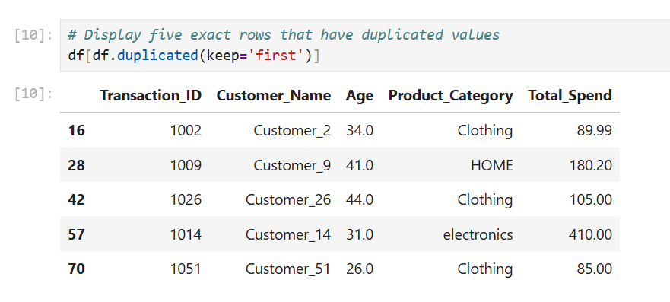
Figure 3.3: Program code and output for displaying the exact duplicated rows
Figure 3.3 shows the program code and output for displaying the exact duplicated rows that have the duplicated values.

Dropping Duplicate Rows
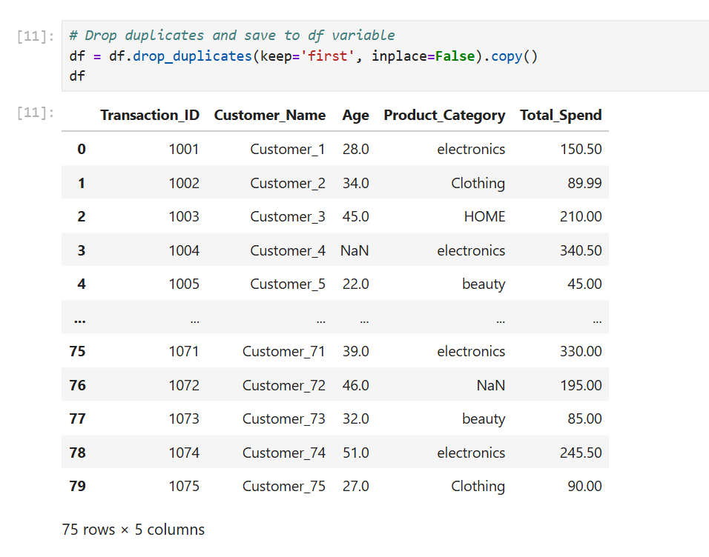
Figure 3.4: Program code and output for dropping duplicate rows
Figure 3.4 shows the program code and output for duplicate rows. The code drops only five rows and as a result the dataset now have 75 rows out of 80 rows from the old dataset. our goal is to remove the identified duplicated rows. To delete duplicated rows, we used the drop_duplicates() function follow with the “keep” parameter that has ‘first’ as its value and the inplace and .copy() function to make sure that the df variable don’t change the original dataset. Since this operation requires changes to the dataset, we made sure to assigned the variable to the default name of the dataset which is “df”. The output in Figure 3.4 above shows the first page of the dataset without the duplicate rows.

Calculating the Age Mean
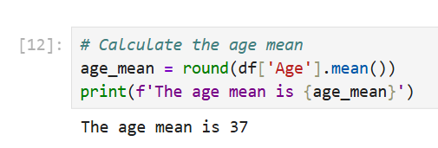
Figure 3.5: Program code and output for age mean
In Figure 3.5 above, we wrote a code to calculate the mean age for the dataset. We assigned the operation with a new variable as it doesn’t make any changes to the dataset. To calculate the mean, we used the mean() function with the addition of round() function because we wanted to make sure the output is a round number since it involves age.

Fill Missing Age with Mean Value
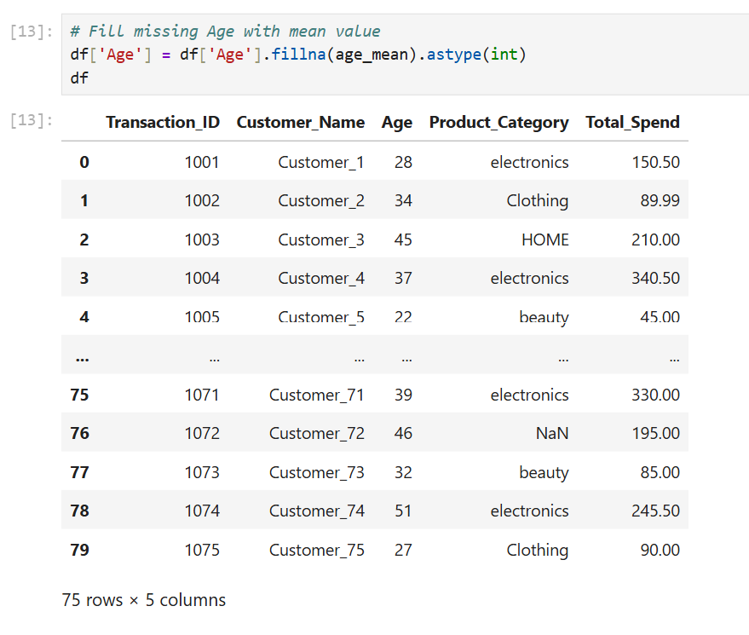
Figure 3.6: Program code and output for filling missing age
Figure 3.6 shows the program code and output for filling missing age with mean value. The code calculates the sum of all ages and divided with 75. The result from the calculation will fill up the missing age with the mean values.

Finding The Product Mode
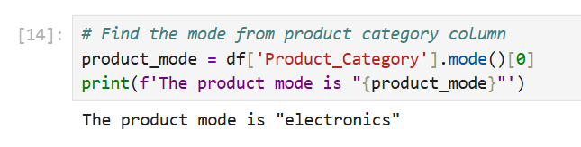
Figure 3.7: Program code and output for finding the product mode
Figure 3.7 shows the program code and output for finding the mode from the Product_Category column. It is stated that the mode is “electronics”.

Fill Missing Product Category Data with Mode Value
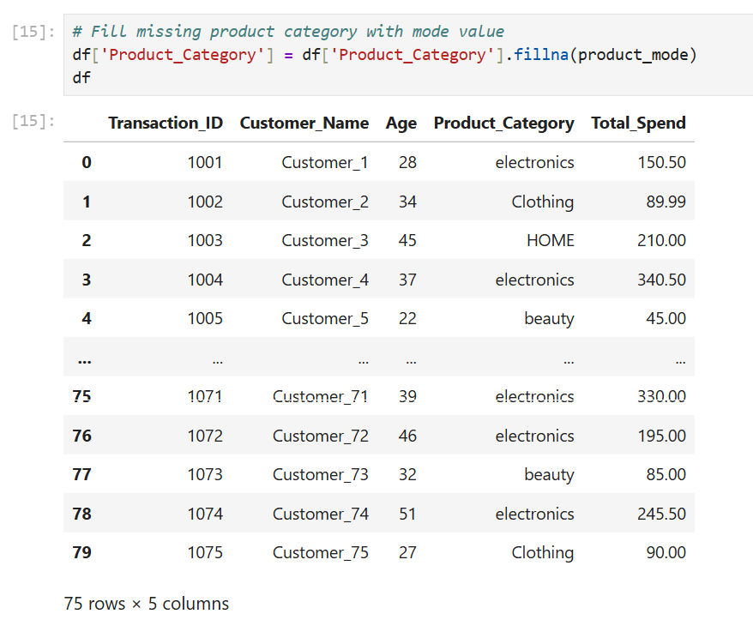
Figure 3.8: Program code and output for filling missing product category
Figure 3.8 shows the program code and output for filling missing product category with mode value. It filled up all the empty or missing data with mode value which is the “electronics” by using the function .fillna(). Similar to the missing data in the age column, we made sure to write a code that made sure that it filled in only the Product_Category column.

Dropping Rows with Missing Customer Name
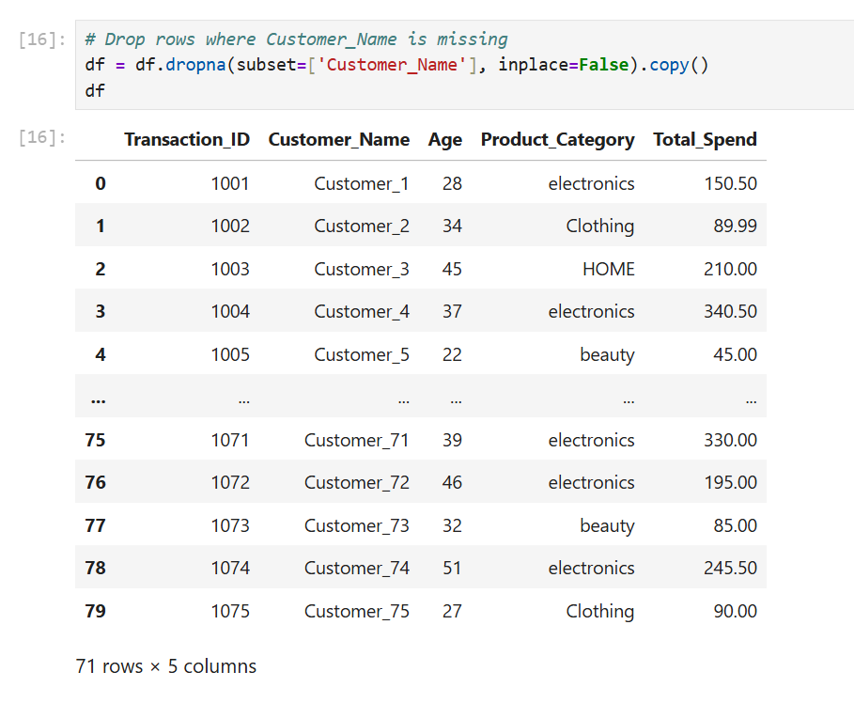
Figure 3.9: Program code and output for dropping rows with missing customer name
Figure 3.9 shows the program code and output for dropping rows with missing customer name. we used the dropna() function with the addition of subset=() condition to make sure that it checks the Customer_Name column for the missing value. The dropna() function will then “drop” the rows that contains missing customer name. Only 4 rows have been dropped and as a result there are only 71 rows were left in the dataset.

QUESTION 3: HANDLING OUTLIERS
In this section, we will discuss and code Python on how to handle the outliers from the dataset. We will first calculate the quartiles and inter quartile range to find the value of the upper bound and lower bound and finally we will the delete the outliers by using the bounds that we have calculated.

Q1 and Q3 Calculation
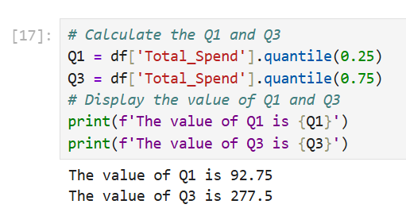
Figure 4.1: Program code and output for calculating Q1 and Q3
Figure 4.1 shows the program code and output for calculating first quartile (Q1) and third quartile (Q3). We use the “.quantile” function to calculate the both quartile and display it using “f” format print.

IQR Calculation
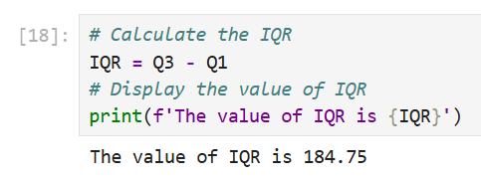
Figure 4.2: Program code and output for calculating IQR
Figure 4.2 shows the program code and output for calculating the IQR (Interquartile Range) value. We subtract it by Q3 - Q1 and get the result for IQR.

Calculations of Lower and Upper Bound
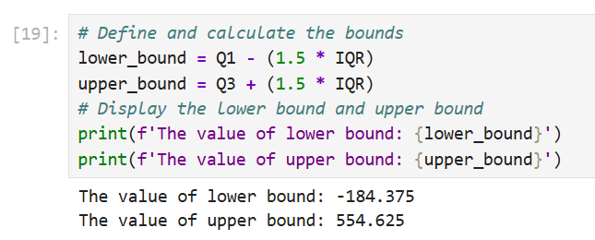
Figure 4.3: Program code and output for calculating the bounds
Figure 4.3 shows the program code and output for calculating the lower bound and upper bound. The lower bound is calculated by Q1 subtracting with 1.5 times with the IQR. Like upper bound where it is calculated by Q3 addition with 1.5 times with the IQR. Finally, we display the result for those bounds.

Filtering the Outliers
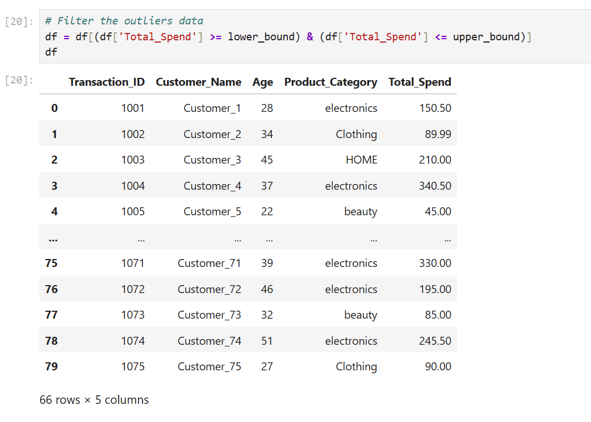
Figure 4.4: Program code and output for filtering the outliers
Figure 4.4 shows the program code and output for filtering the outliers from the dataset. This program removes outliers from a Data Frame using the Interquartile Range (IQR) method and removes 5 outliers from Total Spend, shrinking the dataset from 71 to 66 rows and lowering the mean from 449 to 179. 5 rows were removed as they are identified as outliers and as a result there are 66 rows were left out of 71 rows.

New Shape of The Dataset
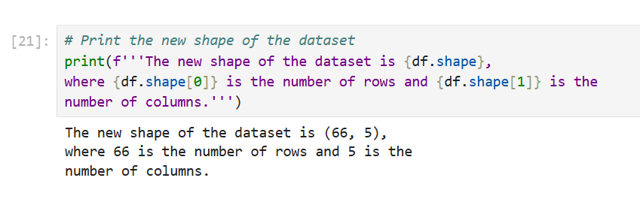
Figure 4.5: Program code and output for printing the new shape
Figure 4.5 shows the program code and output for printing the new shape of the dataset. The new shape are 66 rows and five columns.

QUESTION 4: DATA TRANSFORMATION AND EXPORT
In this section, we will discuss and code Python on how to transform the data and transfer the new dataset into the new csv file. The dataset underwent a cleaning process which resulted in a transformation that enhanced its consistency while enabling future research work. The transformation process created a new categorical variable while text values from existing data were converted into standardized formats.

New Column: Spend Category
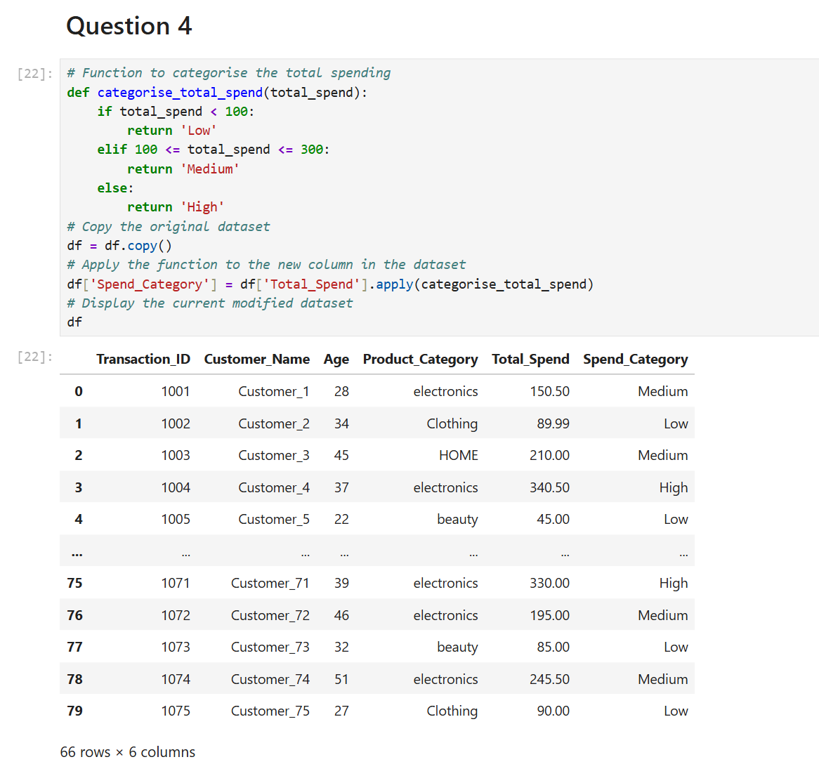
Figure 5.1: Program code and output for new column and categorise the data
Figure 5.1 shows the program code and output for new column Spend_Category and categorise the data of total spend into different category. The data underwent transformation to improve both its usability and its consistency with the dataset which required cleaning. The system established a new column Spend_Category which it generated from the Total_Spend column data. The conditional function was used to divide spending into three distinct spending categories. The system identified transactions with total spending below 100 as Low while spending between 100 and 300 received Medium classification and spending above 300 received High classification.
1. The Logic Function (categorise_total_spend)
This is a conditional function that sorts the numerical values into the three distinct categories required by the rubric.
- if total_spend < 100: Any customer who spent less than 100 is labeled as 'Low'.
- elif 100 <= total_spend <= 300: Customers who spent between 100 and 300 (inclusive) are labeled 'Medium'.
- else: Any value above 300 is automatically labeled 'High'.
2. Creating a Copy (df = df.copy())
- This creates a "deep copy" of your DataFrame.
- It is a safe programming practice that prevents the SettingWithCopyWarning you encountered earlier.
- It ensures that the transformations you are about to make are applied to a fresh, independent version of the cleaned data.
3. Applying the Transformation (.apply)
- df['Spend_Category']: This creates a brand-new column in your dataset.
- .apply(categorise_total_spend): This tells pandas to take every single row in the Total_Spend column and run it through your function to determine the label.
4. Displaying the Result (df)
- Simply typing df at the end displays the table so you can verify the new column exists and the values are correct.

Standardized Product_Category Column
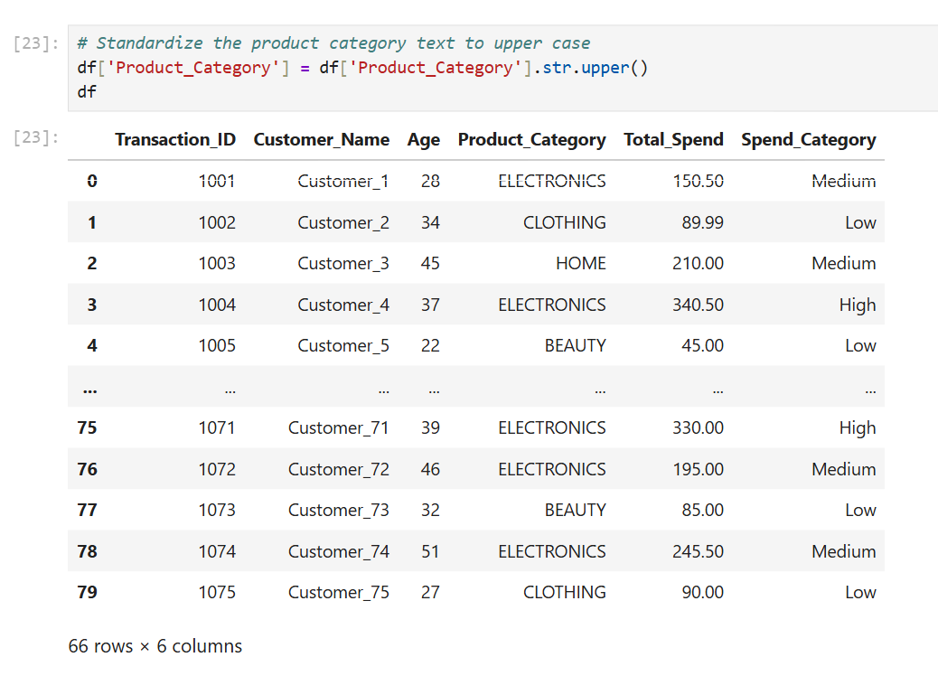
Figure 5.2: Program code and output for standardized product category
Figure 5.2 shows the program code and output for standardized Product_Category column. The str.upper() helps to make every rows of Product_Category column to upper case and finally the df variable is used to display the updated dataset. We standardized the Product_Category column by transforming all text values into uppercase letters. This method maintains consistent categorical values in the dataset because it prevents problems that arise from mixed text case usage.

Save Fully Cleaned and Transformed Dataset
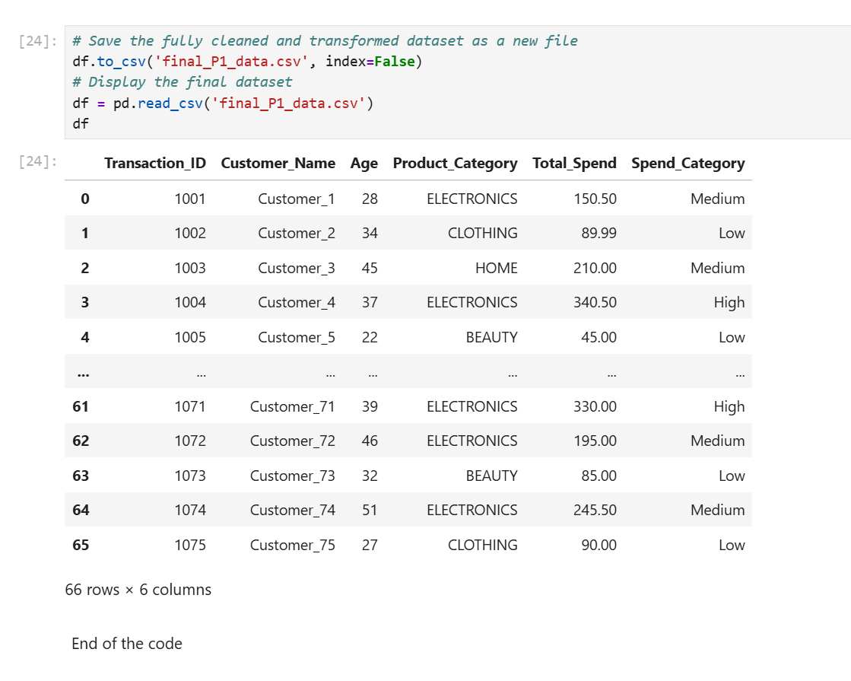
Figure 5.3: Program code and output for saving the new dataset
Figure 5.3 shows the program code and output for saving the new dataset to a new file name final_PQ_data.csv. The to_csv function is used to save the dataset a new file with index=False. Using index=False tells pandas that "Save the data columns only and do not include the row numbers. Finally, the pd.read_csv function is used to display the current new dataset into the jupyter notebook. The cleaned data together with the transformed dataset was saved to a new csv file which received the name final_p1_data.csv. The final dataset contains 66 rows and 6 columns which includes the newly created spend_category column

QUESTION 5: PRESENTATION
In this section, we will make presentation slides and present to our lecturer.
Okay

CONCLUSION
In conclusion, this exercise effectively illustrated how to perform data cleaning, transformation and preparation with the help of Python and Pandas library. The first step involved getting the information about the dataset. Then, we examining the dataset for problems where there were also missing values, duplicate records, and incorrect data types. Data cleaning techniques such as removing duplicate records, ignoring missing values by mean and mode replacement and filtering outliers using Interquartile Range (IQR) were performed on the dataset to improve its quality.
Once the data was cleaned, transformation of data happened so that we can prepare a structured dataset for analysis. Using the Total_Spend values, we created a variable called Spend_Category which divided customers into three categoriesLow, Medium, and High. Moreover, to standardize the Product_Category column all the text values were converted into uppercase.
Finally, the prepared dataset was exported as final_P1_data. csv. In the end we have 66 rows and 6 columns, it means dataset process is done successfully. This hands-on exercise contributed to building crucial abilities such as data preprocessing and highlighted the significance of thoroughly preparing the data ahead of conducting any analyses.

REFERENCES
Coursera Staff. (2025, April 25th). What Is Pandas in Python?. Coursera. https://www.coursera.org/articles/what-is-pandas-in-python?msockid=0431fb56b078694022edec46b1f66850
GeeksForGeeks. (2026, February 17th). Data Cleaning. https://www.geeksforgeeks.org/data-analysis/data-cleansing-introduction/

RUBRIC for Assignment
CLO1 – Perform data cleaning, transformation, and integration techniques using visual programming tools. (P4, PLO3)

COMPONENTS of CRITERIA/  WEIGHTAGE (%) | CRITERIA/  WEIGHTAGE (%) | LEVELS of ACHIEVEMENTS/ DESCRIPTORS |  |  |  |  | TOTAL  SCORE  100 marks
 |  | Excellent  (4) | Good  (3) | Average  (2) | Needs Improvement  (1) | Not Attempted  (0) | 1 | 2 | 3 | 4
Content (40%) | Identification of Data Quality Issues (15%) | Identifies exactly 100% of missing values, duplicate records, and numerical outliers using calculated statistical bounds. | Identifies between 80% and 99% of missing values, duplicate records, and numerical outliers using calculated statistical bounds. | Identifies between 50% and 79% of missing values, duplicate records, and numerical outliers using visual estimations rather than exact statistical bounds. | Identifies fewer than 50% of missing values, duplicate records, and numerical outliers within the dataset. | Does not attempt to identify missing values, duplicate records, or numerical outliers.
 | Execution of Data Cleaning (15%) | Replaces missing numerical data using mean imputation, replaces categorical data using mode imputation, and deletes rows exclusively for missing unique identifiers. | Applies mean or mode imputation for most columns but leaves 1 to 2 null values untreated or deletes 1 to 2 incorrect rows. | Applies a single imputation method across all data types indiscriminately and retains multiple untreated null values. | Deletes entire columns instead of targeted rows and applies incorrect data types during the imputation process. | Does not apply any imputation methods or deletion functions to clean the dataset.
 | Execution of Data Transformation (10%) | Constructs a conditional function to classify numerical spending into exactly three distinct categories and converts all targeted text entries to uppercase. | Constructs a conditional function to classify numerical spending into three categories but omits the uppercase conversion for 1 to 2 text entries. | Constructs a conditional function for categorization but leaves the targeted text entries entirely in their original mixed case format. | Writes the categorization function with fatal syntax errors preventing execution and leaves the text format unmodified. | Does not write a categorization function and does not modify the text case format.
Process (30%) | Code Execution and Library Utilization (10%) | Executes built-in pandas library functions to perform all data manipulation tasks without producing any runtime errors or relying on manual iterative loops. | Executes built-in pandas library functions for the majority of tasks but writes 1 to 2 manual iterative loops resulting in minor recoverable errors. | Executes manual iterative loops for the majority of tasks and requires multiple manual code restarts to process the data completely. | Executes standard Python text functions instead of pandas data manipulation functions resulting in fatal data type errors. | Does not write executable Python code and leaves the programming cells completely blank.
 | Data Import and Workspace Setup (10%) | Loads the designated CSV file into the Google Colab environment using the pandas library without requiring any manual file path adjustments. | Loads the designated CSV file into the Google Colab environment but requires 1 to 2 manual code adjustments to the file path to execute successfully. | Loads the designated CSV file into a local offline environment instead of utilizing the required Google Colab workspace. | Writes the pandas import statement but fails to load the designated CSV file into the programming environment. | Does not write the pandas import statement and does not load the designated CSV file.
 | Workflow Sequencing and Logic (10%) | Sequences the operational steps in chronological order from raw data import to final data export without placing any cleaning tasks after the transformation phase. | Sequences the operational steps chronologically for the most part but places exactly 1 cleaning task incorrectly after the transformation phase. | Sequences the operational steps out of order requiring the user to run notebook code blocks non-linearly to achieve the final output. | Scrambles the operational steps completely causing fatal data dependency errors during code execution. | Does not arrange the operational steps into any sequence and submits unorganized code blocks.
Product (30%) | Completeness of the Cleaned Dataset (15%) | Outputs a final exported CSV file containing exactly 0 duplicate records, 0 null values, and the newly categorized spending column without the programming index. | Outputs a final exported CSV file containing 0 duplicate records but retains 1 to 2 null values or accidentally includes the programming index. | Outputs a final exported CSV file containing 1 to 2 duplicate records and omits the required categorized spending column entirely. | Outputs a corrupted or empty final CSV file that retains 3 or more duplicate records and multiple null values. | Does not output a final dataset and does not generate an exported file.
 | Written Summary and Communication of Findings (10%) | States the starting row count, lists the exact cleaning and transformation functions applied, and states the final row count in the written summary document. | States the starting row count and lists the applied functions but omits the final row count in the written summary document. | States the starting row count but omits both the applied functions and the final row count in the written summary document. | Omits the starting row count, the applied functions, and the final row count resulting in an incomplete written summary document. | Does not submit a written summary document to communicate findings.
OVERALL SCORE

